

NCIA – National Cancer Imaging Archive

Software Design Description

Release 2.0 – HTTP Link to Images


Document Change Record
Version Number | Date | Description
1.0 | 06/23/06 | Initial document
1.1 | 07/11/06 | Revisions after finalization of use cases with I-Spy team

TABLE OF CONTENTS
1. Introduction 1
1.1 PROJECT BACKGROUND 1
1.2 SYSTEM OVERVIEW 1
1.3 Requirements Traceability 2
1.3.1 Relevant Statement of Work Tasks 2
2. Use Cases 3
2.1.1 New Use Cases 3
2.1.2 Perform Search Based on Link from Another Application 3
2.1.3 Changes to Existing Use Cases 4
2.1.4 Display Search Results Use Case 5
2.1.5 Save Query Use Case 6
2.1.6 Login Use Case 7
3. System Architecture 9
4. configuration 10
4.1 Add new servlet filter to web.xml 10
4.2 FACES-CONFIG.XML and tiles.xml 10
5. Sequence diagrams 11
5.1 Perform Search Based on Link from Another Application 11
6. Components 12
6.1 referencing APPLICATION 12
6.1.1 Example 13
6.2 USER INTERFACE 13
6.2.1 Referenced Image Page 13
6.2.2 Display Full Size JPEG Page 15
6.2.3 Navigation Bar 15
6.2.4 Search Results (by Subject) Page 15
6.2.5 Search Results (Studies for Subject) Page 16
6.2.6 Search Results (Images for Series) Page 16
6.3 User interface Backing Beans 16
6.3.1 ThumbnailImageDTO 16
6.3.2 SearchWorkflowBean 16
6.3.3 SearchResultsBean 17
6.3.4 SecurityBean 17
6.3.5 RegisterBean 17
6.4 MIDDLE TIER 17
6.4.1 UrlParamCriteria 17
6.4.2 DICOMQuery 18
6.4.3 DICOMQueryHandler 18
6.4.4 DICOMSeriesQueryHandler 18
6.4.5 ImageResultSet 18
6.4.6 ResultSetManager 18
6.5 UTILITIES 18
6.5.1 URLParameterFilter 18
6.5.2 ReportingDataStorageManager 19
6.5.3 NameValuePair 19
6.6 BACK END 19
6.6.1 Domain Classes 19
6.6.2 Database Design 19
6.6.3 Views 19
6.6.4 Indexes 19

Introduction
The purpose of this document is to describe the design for the HTTP Link feature being developed for Release 2.0 of the NCIA – National Cancer Imaging Archive software.
The enhancement will provide new functionality to allow other applications to link to NCIA and pass some search parameters in the URL. After the user logs in, NCIA will automatically perform a search based on the search parameters passed. A new page will be created that shows two images side by side as requested by the URL parameters.

PROJECT BACKGROUND
Please refer to the NCIA Architecture Overview for background on the NCIA project.

SYSTEM OVERVIEW
Please refer to the NCIA Architecture Overview for a system overview.
.

Requirements Traceability

Relevant Statement of Work Tasks
The NCIA Statement of Work (SOW) Task Description contains the following items that will be implemented as part of this design:
4.1.13 Ability to create HTTP link to NCIA from another application (4.2.1)

This task involves providing an URL for another application to link to NCIA and automatically run a query based on de-identified patient, study and series UID in NCIA database. The query results will be restricted by the login user’s authentication and authorization privileges. The resulting images will be displayed side by side on the result page. User will be able to download the resulting images.

When a user clicks the link from another application, they will be taken to the NCIA login page. Immediately after a successful login, they will be presented with the results of a query.

Use Cases
User preferences requirements were documented by a combination of adding new use cases and updating existing use cases.

New Use Cases

Perform Search Based on Link from Another Application
Use Case Name | Perform Search Based on Link from Another Application
Use Case ID | 9.3
Primary Actor | Researcher (User), Other Application
Trigger | User clicks a link to NCIA that is included in another application.
Pre-conditions | Other application created a link to NCIA and passed one of the following in the URL:  - Source (i.e. “I-Spy”)  - Image 1 Data  - Label  - Trial ID  - Patient ID  - Study Instance UID  - Series Instance UID  - Image SOP Instance UID  - Field Name (zero to many)  - Field Value (zero to many)  - Image 2 Data (optional)  - Label  - Trial ID  - Patient ID  - Study Instance UID  - Series Instance UID  - Image SOP Instance UID  - Field Name (zero to many)  - Field Value (zero to many)
Flow of Events | - User clicks link to NCIA in Other Application.  - Login Page is displayed.  - User logs into NCIA (see use case 8.2)  - A query is built based on the trial ID, patient ID, study instance UID, Image SOP instance UID passed in the URL.  - Calls use case 9.6 (Filter Data in Results Based on CSM Authorization) to enforce authorization rules for the user.  - System displays one or both of the images requested along with name value pairs passed in the URL.  - User clicks the “View Full Size JPEG” button.  - Another browser window opens displaying a full size JPEG of the image.  - User clicks the “View Series” link. System calls use case 10.1 step 6 to display the images for the series.
Post-Conditions | . The page has links to add the images to the data basket or navigate to the results page for the series containing the images.
Alternative Flow | - User has not previously registered in NCIA. User clicks the Register button and registers (see use case 8.1 – Register User). After registration is successful, query is built and executed and results displayed as described above.  - User is not authorized to view the search results. The results list is empty.  - User clicks the link after they have already logged into NCIA. As long as their session has not expired and they have not closed their browser, they are immediately presented with the results page instead of having to log in.
Related Use Case | 8.1 - Register User  8.2 - Login User  9.6 - Filter Data in Results Based on CSM Authorization  10.1 – Display Search Results

Changes to Existing Use Cases
The changes relevant to this enhancement are highlighted in purple.

Display Search Results Use Case

Use Case Name | Display Search Results Use Case
Use Case ID | 10.1
Primary Actor | Researcher (via Simple/Advanced Search)
Secondary Actor | Image data store  Annotation Database
Trigger | System has successfully retrieved the user requested data for display
Pre-conditions | - The query is executed without any system errors.
Flow of Events | - The system has successfully retrieved the data requested by the user.  - The search results page includes a list of subjects sorted by Subject ID that have at least one visible series matching the criteria. For each subject, the results include:  - Subject ID  - Trial ID  - The number of studies and series for the patient that contain at least one visible image meeting the criteria.  - The total number of studies and series for the patient.  - A “Show Studies” link.  - The actor can click on the Show Studies link to “drill down” to the study level.  - The Search Results (Studies for Subject) page is displayed. It includes a list of all of the studies or the selected subject (sorted by study date) that contain at least one visible series matching the criteria. For each study, the following is displayed:  - Study ID  - Study Description  - Study Date  For each study, a list of series (ordered by series number) for the study that have been marked as visible matching the criteria is displayed. For each series, the following is displayed:  - Series ID  - Total Number of Images in the Series  - Note: This number includes both visible images that meet the criteria and those that don’t.  - Series Description  - Series Modality  - Series Equipment Manufacturer  - Whether or not annotations exist for the series. If curation data exists to describe the content type of the series’ annotation files, display all available content types.  - A “Show Images” Link  - The user clicks the “Show images” link to display the visible images in that series.  - The system displays a set of thumbnails for all the images in the series with a QA status of Visible sorted by the image date. (Thumbnails for visible images that do not match the criteria are displayed also). A summary of the series is also displayed that includes whether or not the user has annotations and the content types of the annotation files if there is available curation data to describe the content type.
Post-Conditions | Success Condition: User views the results.
Alternative Flow | - If no data is returned by executing the query, an appropriate message is returned to the search results page.  - On the subject's page, the user clicks on the icon in a column title to sort the list by the data in that column.  - User clicks a link to go back and view the search page. System executes use case 9.1. This option is not available if the search results were created by linking from another application (see use case 9.3).
Related Use Case | 11.4 Add to Data Basket Use Case

Save Query Use Case

Use Case Name | Save Query
Use Case ID | 12.1
Primary Actor | Researcher (User)
Trigger | User wants to save the query for future use.
Pre-conditions | User has performed a search (simple or advanced) and is viewing the results of the search on the Search Results page. The search was conducted using a query that is not already saved.
Flow of Events | 1. User enters a name to call the saved query.  2. User presses the “Save Query” button.
Post-Conditions | Success Condition: The query is saved in the database for the user. User is returned to the Search Results page with a message indicating that the query has been saved successfully. The message includes the name of the query. The last executed time for the saved query is updated to the current date and time. The new data flag for the saved query is set to false.  Error Condition: A query with that name already exists for this user. The user is returned to the Search Results page with an error message displayed. The query is not saved, but the user has the opportunity to enter a new name for the query.  Error Condition: User does not enter a name for the query and presses the “Save Query” button. The user is returned to the Search Results page with an error message indicating that the query name is required. The query is not saved, but the user has the opportunity to enter a name for the query.
Alternative Flow | User executed the query by linking from another application (see use case 9.3). The option to save the query is not displayed.
Related Use Case | 10.1 – Display Search Results

Login Use Case

Use Case Name | Login Use Case
Use Case ID | 8.2
Primary Actor | Researcher (User), CSM Data
Trigger | Researcher navigates to the NCIA Imaging URL
Pre-conditions | Successful navigation to the NCIA Imaging URL.  Researcher is registered and has entered a user ID/password to use the system.
Flow of Events | - The system waits for user to enter Login ID and Password.  - The user enters the login information and presses the Login button  - The system validates login information against the CSM registered user database.  - If the user ID/password matches an entry in the user table, the system successfully logs the user into the system and displays the main page with the menu selection.  - An entry is created in the login history table containing the date and time, the login source (defaults to NCIA) along with the IP address of the user.
Post-Conditions | Success Condition: User is granted access to the NCIA Imaging System.  Error Condition: Invalid User  Error Condition: Invalid Password  Error Condition: System Error
Alternative Flow | If an invalid user or password error is thrown, the login form is redisplayed and the user is asked to reenter user ID/password or the user can click on the register user link for registration.  If a system error is thrown, the researcher is asked to contact the system administrator to report the type of error thrown.  User accessed NCIA by clicking a link in another application (see use case 9.3). The login history record that is created will contain the value passed as the source in the URL.
Related Use Case | 8.1 Register User

System Architecture

No changes are being made to the NCIA architecture for this enhancement.

configuration

Add new servlet filter to web.xml
A new servlet filter (see section 6.5.1) is being added to extract any parameters passed in the URL and store them in the HTTP session. For the servlet filter to run, it must be configured in web.xml. The following will be added to web.xml:
<filter>
<filter-name>URL Parameter Filter</filter-name>
<filter-class>gov.nih.nci.ncia.util.URLParameterFilter</filter-class>
</filter>

<filter-mapping>
<filter-name> URL Parameter Filter </filter-name>
<url-pattern>/faces/*</url-pattern>
</filter-mapping>

FACES-CONFIG.XML and tiles.xml
Changes to this file must be made for the new page being added (see section 6.2.1). Tiles must be configured so that the new page is accessible via the URL described in section 6.1.

Sequence diagrams
For some use cases, sequence diagrams are helpful to illustrate the execution flow. Sequence diagrams are included this section for the appropriate use cases. Details of the objects that participate in the use cases are described in section 6.

Perform Search Based on Link from Another Application
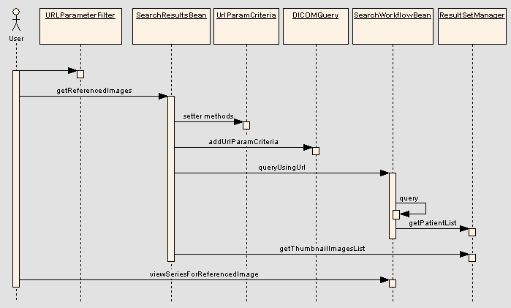

Components

referencing APPLICATION
The referencing application is responsible for constructing a link to NCIA containing the parameters. The link must be built as follows:
[http,https]://[server:port]/ncia/faces/referencedImages.tiles?{paramName=paramValue}
The protocol, server and port will vary depending on the NCIA instance being linked to. The parameters passed are as follows:
Parameter | Description | Validations
source | Identifier for the application creating the link. At this time, NCIA will not do anything with the data passed except to store it for reporting purposes as the login source. | Required – occurs only once
image1Label | Label for image 1 | Required – occurs only once
image1TrialId | Trial ID of image 1 as added to DICOM header by MIRC field center | Required – occurs only once
image1PatientId | Patient ID (DICOM field 0010,0020) of image 1 | Required – occurs only once
image1StudyInstanceUid | Study Instance UID (DICOM field 0020,000D) of image 1 | Required – occurs only once
image1SeriesInstanceUid | Series Instance UID (DICOM field 0020,000E) of image 1 | Required – occurs only once
image1ImageSopInstanceUid | SOP Instance UID (DICOM field 0008,0018) field of image 1 | Required – occurs only once
image1dataName | Name of one of the data items related to image 1 | Optional  Can occur multiple times
image1dataValue | Value of one of the data items related to image 1 | Optional  Can occur multiple times
image2Label | Label for the image 2 | Required if there are two images – occurs only once
image2TrialId | Trial ID of image 2 as added to DICOM header by MIRC field center | Required if there are two images – occurs only once
image2PatientId | Patient ID (DICOM field 0010,0020) of image 2 | Required if there are two images – occurs only once
image2StudyInstanceUid | Study Instance UID (DICOM field 0020,000D) of image 2 | Required if there are two images – occurs only once
image2SeriesInstanceUid | Series Instance UID (DICOM field 0020,000E) of image 2 | Required if there are two images – occurs only once
image2ImageSopInstanceUid | SOP Instance UID (DICOM field 0008,0018) field of image 2 | Required if there are two images – occurs only once
image2dataName | Name of one of the data items related to image 2 | Optional  Can occur multiple times
image2dataValue | Value of one of the data items related to image 2 | Optional  Can occur multiple times

The name value pairs are processed in order; the first image1dataName parameter will be matched up with the image1dataValue parameter. There must be a data value for each data name.
Any characters that need to be escaped (such as whitespace) must be properly escaped by the referencing application as described at http://java.sun.com/j2se/1.5.0/docs/api/java/net/URLEncoder.html.

Example
https://imaging.nci.nih.gov/ncia/faces/referencedImages.tiles?source=ISPY&image1Label=Pre&image1TrialId=ISPY&image1PatientId=1.3.6.1.4.1.9328.50.1.0001&image1StudyInstanceUid=1.3.6.1.4.1.9328.50.1.2&image1SeriesInstanceUid=1.3.6.1.4.1.9328.50.1.3&image1ImageSopInstanceUid=1.3.6.1.4.1.9328.50.1.39408&image1dataName=Longest%20Diameter&image1dataValue=25&image1dataName=XXXX&image1dataValue=1111&image2Label=Post&image2TrialId=ISPY&image2PatientId=1.3.6.1.4.1.9328.50.1.0001&image2StudyInstanceUid=1.3.6.1.4.1.9328.50.1.4&image2SeriesInstanceUid=1.3.6.1.4.1.9328.50.1.5&image2ImageSopInstanceUid=1.3.6.1.4.1.9328.50.1.39408&image2dataName=Longest%20Diameter&image2dataValue=18&image2dataName=YYYY&image2dataValue=564

USER INTERFACE

Referenced Image Page
A new page will be added to display the referenced image(s) and associated data.
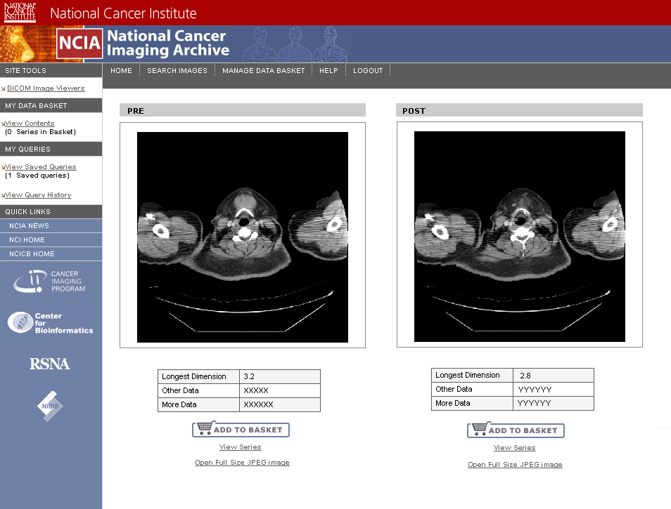
Upon loading the page, the getReferencedImages() method of SearchResultsBean is called. This performs a search based on the URL parameters and returns a list of ThumbnailImageDTOs. The images and associated data are displayed based on the DTO. If there is only one DTO in the returned list, only one image is displayed.
There are several actions the user can take while on the page:
- “Add to Basket” button will call BasketBean to add the DTO to the data basket.
- “View Series” – calls SearchWorkflowBean.viewSeriesForReferencedImage().
- “Open Full Size JPEG” – Launches the Display Full Size JPEG page (see section 6.2.2) in a separate browser window. The “target” of the link will be set such that the following is true:
  - JPEGs will appear in a separate browser window from NCIA
  - Each image will appear in its own window
  - If a user clicks an image more than one, it will take the user to the existing window that displays the image, not open multiple windows showing the same image.
- Click the image – same action as “Open Full Size JPEG”
No breadcrumbs are displayed on this page because when there are two images it cannot be determined which series, or patient to display. Once users have clicked “View Series”, they will have access to breadcrumbs and normal navigation with the search results.
If getReferencedImages does not return any results, display the following message: “Images could not be found based on data passed in”.
If a user attempts to access this page without logging in, existing logic in SecurityCheckFilter will redirect the user to the login page.

Display Full Size JPEG Page
This page will display the full size JPEG for the image. This browser window will not have any controls (back button, URL bar, etc).
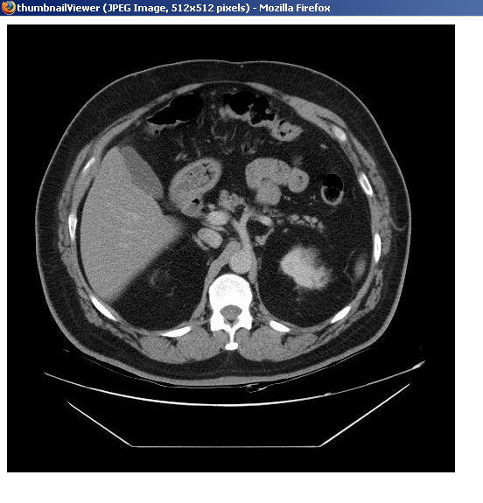

Navigation Bar
A new “Referenced Images” link will be added in the left side navigation bar under the “My Queries” section. The link will only appear when the search results being viewed were generated by sending parameters in the URL (SearchResultBean.query.isQueryFromUrl).

Search Results (by Subject) Page
To prevent the user from attempting to edit the query, the “Search” breadcrumb and the “Save Query” button and text box must be disabled (not clickable) when the search results being viewed were generated by sending parameters in the URL (SearchResultBean.query.isQueryFromUrl).

Search Results (Studies for Subject) Page
To prevent the user from attempting to edit the query, the “Search” breadcrumb must be disabled (not clickable) when the search results being viewed were generated by sending parameters in the URL (SearchResultBean.query.isQueryFromUrl).

Search Results (Images for Series) Page
To prevent the user from attempting to edit the query, the “Search” breadcrumb must be disabled (not clickable) when the search results being viewed were generated by sending parameters in the URL (SearchResultBean.query.isQueryFromUrl).

User interface Backing Beans

ThumbnailImageDTO
This class will have additional attributes to contain data that can be displayed on the referenced images page.
Attribute | Type | Description
label | String | Description of the image passed from referencing application.
nameValuePairs | HashMap | Map of all name value pairs associated with the image by the referencing application.
sopInstanceUid | String | SOP Instance UID of the image

SearchWorkflowBean
New Method Name | Description
queryUsingUrl | Retrieves all URL parameters from the HTTP session using the urlParam object. Validates the URL parameters based on the rules described in section 6.1. If there is a validation error, an exception is thrown. Creates a UrlParamCriteria object based on the URL parameters and adds them to a DICOMQuery object. The DICOMQuery object is then passed to the query() method. The parameter isQueryFromUrl is set to true on DICOMQuery.

SearchResultsBean
New Method Name | Description
getReferencedImages | Calls queryUsingUrl() to populate the patient list in the search results. For each series retrieved (either one or two), call ResultSetManager.getThumbnailImagesList() to get a list of ThumbnailImageDTOs. Within those lists, find the DTOs that correspond to the requested images using the SOP instance UID passed in. Populate the DTOs with the label and name value pairs passed in the URL. Return a list containing the DTOs for the requested images. If there is an exception or problem of any kind, return an empty list that will trigger an error message to appear as described in section 6.2.1
viewSeriesForReferencedImage | Populates the patient, study, and series attributes of SearchResultsBean and then returns the appropriate string to redirect the user to the Images for Series page. The logic for populating the attributes will be similar to the viewPatient() and viewSeries() methods.

SecurityBean
In the existing login() method, call SearchWorkflowBean.searchParamsPassedInUrl() to determine if any search parameters were passed in the URL. If the result is true, return a value that will redirect the user to the Referenced Images page.

RegisterBean
In the existing register() method, call SearchWorkflowBean.searchParamsPassedInUrl() to determine if any search parameters were passed in the URL. If the result is true, return a value that will redirect the user to the Referenced Images page.

MIDDLE TIER

UrlParamCriteria
A new transient criteria class named UrlParamCriteria will have the following attributes:
- Patient ID
- Study Instance UID
- Series Instance UID
- Image SOP Instance UID

DICOMQuery
New methods must be added to DICOMQuery to support the new types of criteria.
New Method Name | Description
addUrlParamCriteria | Adds a UrlParamCriteria to the list
getUrlParamCriteria | Gets list of UrlParamCriteria
setQueryFromUrl | Allows a flag to be set indicating that this query was initially created from parameters passed in the URL.
isQueryFromUrl | Returns true if query was initially created from parameters passed in a URL.

DICOMQueryHandler
This class builds an HQL query based on the criteria passed in. It must be changed to add conditions to the where clause based on UrlParamCriteria objects contained in the DICOMQuery. Since queries return data at the series level, it is not necessary to add the image SOP instance UID to the HQL. The conditions must be structured so that series returned must match on the combination of Patient ID, Study Instance UID, and Series Instance UID. All required domains are already joined in the HQL.

DICOMSeriesQueryHandler
HQL in this class must be changed to return the SOP instance UID of the image and place it into the ImageResultSet objects that are returned.

ImageResultSet
A new attribute sopInstanceUid will be added.

ResultSetManager
The getThumbnailImagesList() method will be changed to populate the SOP instance UID on the DTO from the result set.

UTILITIES

URLParameterFilter
URLParameterFilter is a new servlet filter that looks at the HTTPServletRequest to determine if there are any URL parameters. If there are, it adds them to the urlParams object in the HTTP session. urlParams is a Map<String, List<String>> that stores each parameter passed in and each of its values.
If a urlParams object already exists in the HTTP session, all of its stored params will be removed and replaced with the new ones.

ReportingDataStorageManager
Change to set the source attribute of the LoginHistory object that is created. The source attribute is populated based on the ‘source’ attribute passed in the URL. If no such attribute is passed, set the ‘source’ attribute to ‘NCIA’.

BACK END

Domain Classes

LoginHistory
Description: Add new attribute to store source of login.
New Attributes:
New Attribute Name | Attribute Type | Description
Source | String | System from which the login originated (e.g. NCIA, I-Spy).

Database Design

LOGIN_HISTORY
Table: LOGIN_HISTORY
New columns:
New Column Name | Column Type | Class / Attribute Name
SOURCE | VARCHAR2(300) | LoginHistory.Source
.

Views
No changes.

Indexes
Indexes will be added to the following columns since functionality is being added to search on them:
- PATIENT.PATIENT_ID
- STUDY.STUDY_INSTANCE_UID
- GENERAL_SERIES.SERIES_INSTANCE_UID

